Tables:
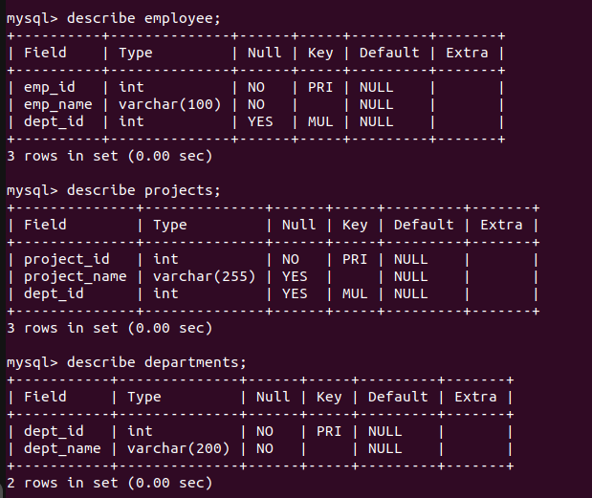
1. Write an SQL query to retrieve all employee names along with their department names.
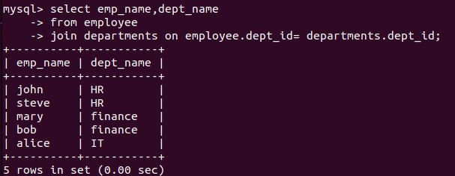
2. Write an SQL query to retrieve all employees and their corresponding project names. Include employees who are not assigned to any project.
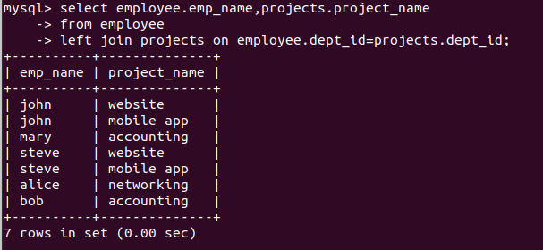

3. Write an SQL query to retrieve all projects and the employee names assigned to each project,
including projects with no employees.
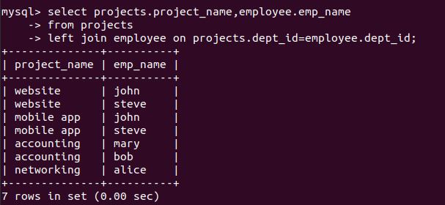
4. Write an SQL query to get all employees and their department names, including employees who have no department and departments with no employees.
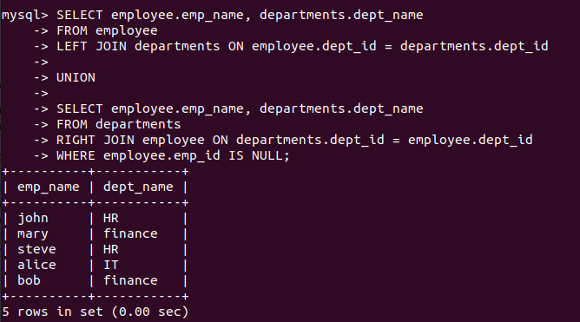
5. Write an SQL query to find employees who work in the same department as "John".

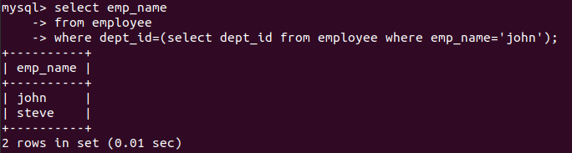

6. Write an SQL query to find the total number of employees in each department.
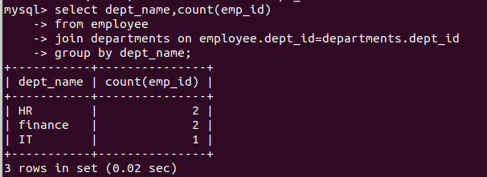
7. Write an SQL query to find how many employees belong to each department.

8. Write an SQL query to find employees who belong to the "HR" department and have a project
assigned.
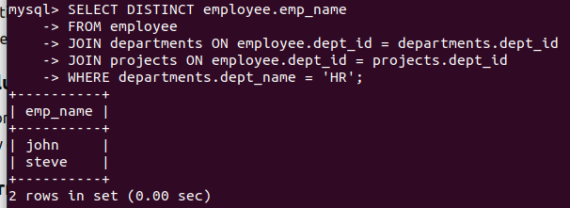
9. Write an SQL query to find employees whose name starts with "S" and their department.
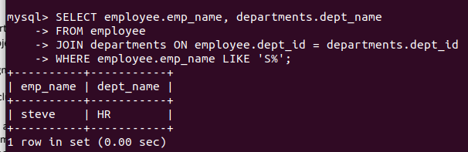
10. Write an SQL query to retrieve employee names, department names, and project names for employees who have projects.
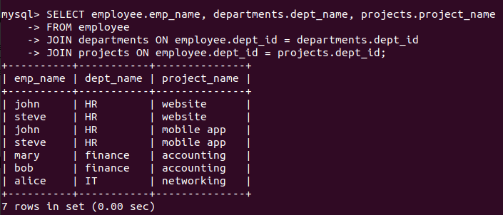
11. Write an SQL query to find all departments that have at least one employee.
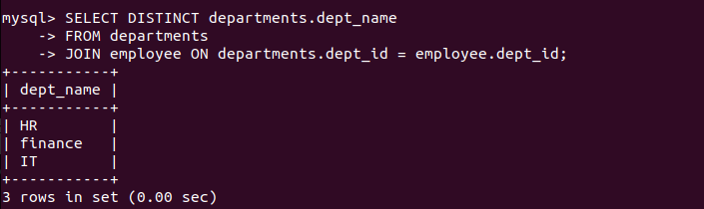
12. Write an SQL query to find employees who belong to the department where "Steve" works.
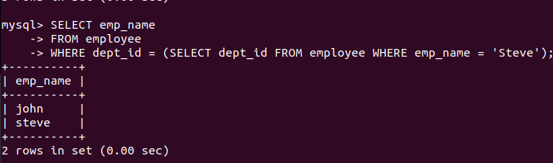
13. Write an SQL query to find all employees who do not have a project assigned.

There are no employees with zero projects.

14. Write an SQL query to find employees who are not working on any project related to the "HR" department.
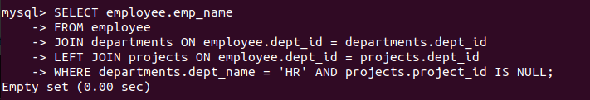
15. Write an SQL query to find all unique departments where employees are working.
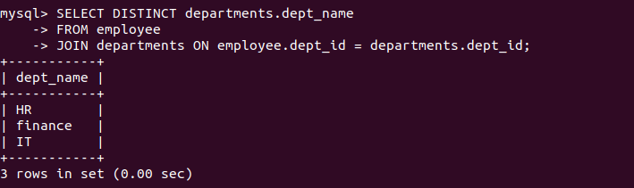
16. Write an SQL query to list all employees sorted by their department and name.
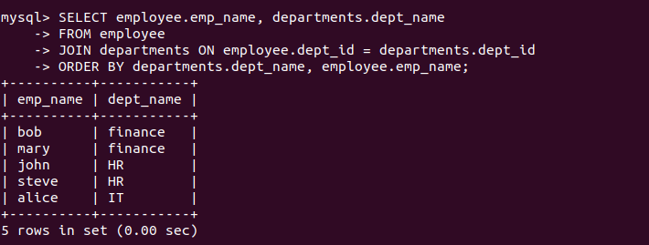
17. Write an SQL query to retrieve the Cartesian product of employees and projects.
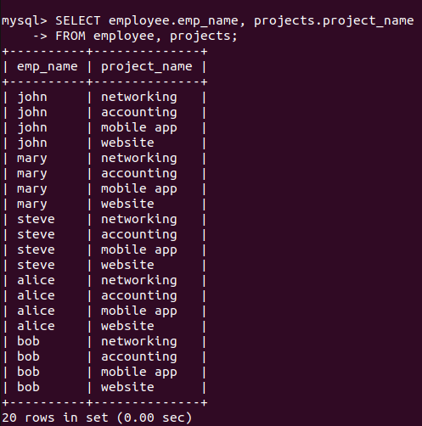
18. Write an SQL query to find departments that have more than 1 employee working in them.
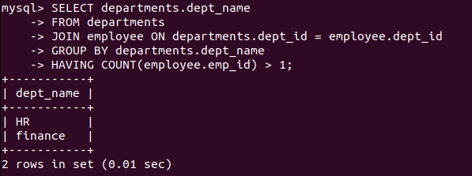
19. Write an SQL query to find employees who share the same department as "Alice", excluding Alice herself.
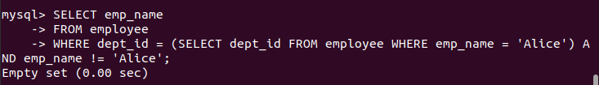
20. Write an SQL query to find employees working in departments with IDs between 101 and 102.
